Doodling Increases Focus and Recall

Jason Fitzpatrick
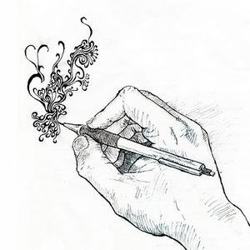
It turns out that your daydreaming doodles of infinite awesomeness not only help with long meetings, but can also help you remember what goes on during the meeting.
In a study, scientists asked subjects to recall what they'd just heard in recordings—with some having doodled throughout, others not. The doodlers demonstrated significantly higher recall than the non-doodlers.

"People may doodle as a strategy to help themselves concentrate," said study co-author Jackie Andrade, a University of Plymouth psychologist. "We might not be aware that we're doing it, but it could be a trick that people develop because it helps them from wandering off into a daydream."

How does it work? The scientists hypothesize the mental load it takes to absentmindedly draw is significantly smaller than the demands of a full-on fantasy, which leads your mind entirely away from the event you're supposed to be engaged in. That trickle of attention devoted to doodling appears to keep you focused in the present time, while giving you a release valve from a frustratingly over-long group session.

It should be noted that the doodling test subjects were doing some light doodling, like shading in boxes. So while abstract or simple shapes might be okay for your focus, try to scale it back if you find yourself crafting elaborate panoramas of medieval battle fields and epic space operas. Then again, your inspired re-imagining of the Sistine Chapel during the report on last quarter's profits per share might suggest a larger career assessment is in order.

